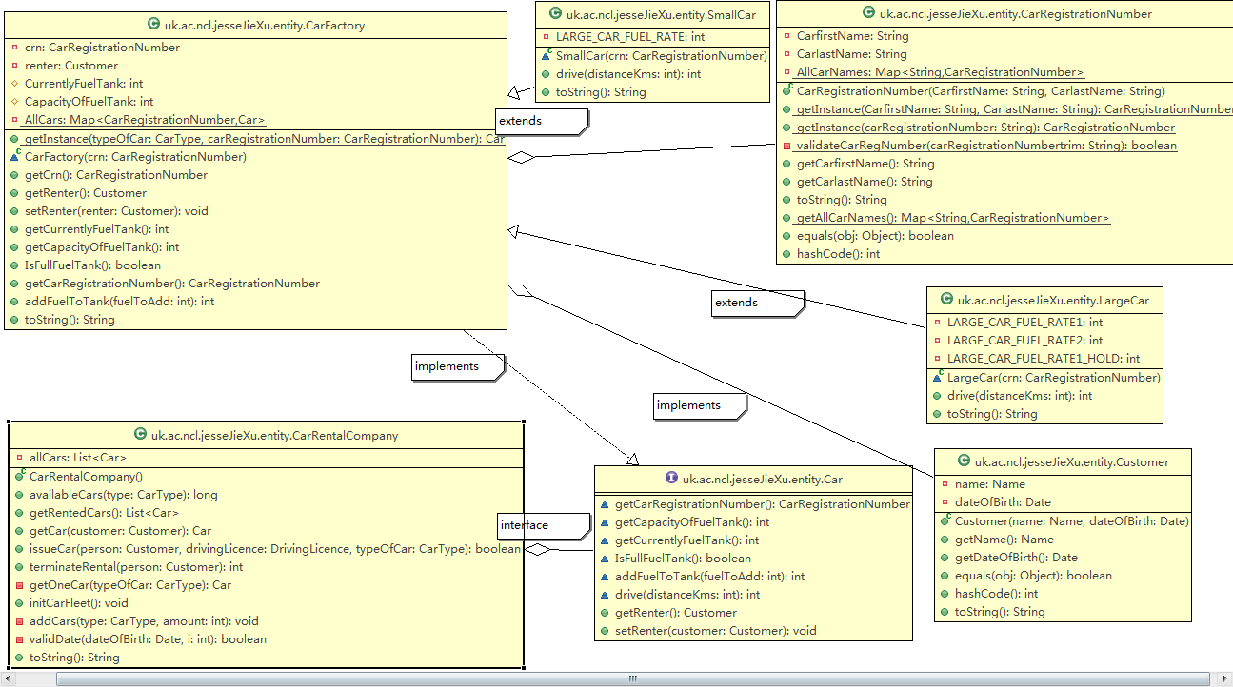
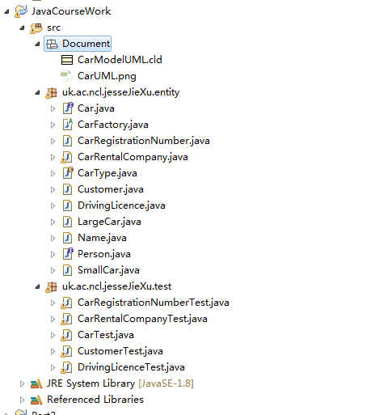
advanced programming in java
JIE XU

As shown in the figure above, the Car Rental application,:

CarFactory. abstract:
According car type(small car, large car) Registration car Number
Add fuel for car

Car. interface:
a method to get the car's registration number
a method to get the capacity in whole Litres of the car's fuel tank
• a method to get the amount of fuel in whole Litres currently in the fuel tank
a method that indicates whether the car's fuel tank is full or not
a method to add a given number of whole Litres to the fuel tank (up to the tank's capacity) and which, after execution, indicates how much fuel was added to the tank
a method to "drive" the car for a given number of whole Kilometres that returns the number of whole Litres of fuel consumed during the journey

CarRegistrationNumber.class :
Instance Car Registration
CarNumber k = CarfirstName + CarlastName
CarfirstName: two letters followed by two digits
CarlastName: three letters

CarRentalCompany.class:
availableCars: returns the number of cars of the specified type that are available to rent.
getRentedCars: returns a collection of all the cars currently rented out
getCar: Given a person, this method returns the car they are currently renting
issueCar: Given a Person (the rentor), the person's DrivingLicence and a specification of the type of car required (small or large)
terminateRental:rent car to people
getOneCar: get car
addCars: add car to company map
validate: compare date
toString: override toString

CarType :
2type car: small car and large car

Customer:
Set Customer name and data

DrivingLicence :
Check the Driving Licence The first component is the concatenation of the initial of the first name of the driver with the initial of the last name of the driver. The second component is the year of issue of the licence. The third component is an arbitrary serial number. For example, the string representation of the licence number for a licence issued to JIE XU in 1994 would have the form:
• JX-1994-03

LargeCar and SmallCar:
calculates the amount of fuel consumed during a journey
large car : fuel at the rate of 10 Kilometres/Litre for the first 50 Kilometres of a journey and then at the rate of 15 Kilometres/Litre for the remainder of the journey
small car : consumes fuel at the rate of 20 Kilometres/Litre
• The tank capacity of a small car is 49 Litres. /a large car is 60 Litres

Customer-person-name:
create ImmutablePerson

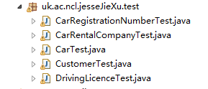
Here is test class

